Assignment 2:

Q1:

#include <stdio.h>

void main() {

int marks[] = {45, 60, 75, 90};

int n = sizeof(marks) / sizeof(marks[0]);

printf("Original Marks: ");

for (int i = 0; i < n; i++) {

printf("%d ", marks[i]);

}

for (int i = 0; i < n; i++) {

marks[i] += 5;

}

printf("\nUpdated Marks: ");

for (int i = 0; i < n; i++) {

printf("%d ", marks[i]);

}

}

Output:

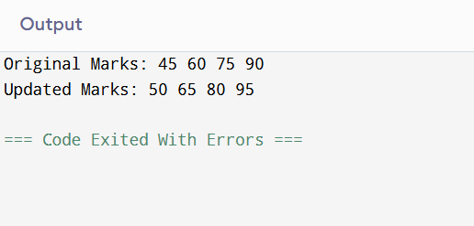

Q2:

#include <stdio.h>

void main() {

int marks[] = {85, 73, 55, 30};

int n = sizeof(marks) / sizeof(marks[0]);

printf("Grades:\n");

for (int i = 0; i < n; i++) {

if (marks[i] >= 75)

printf("Marks: %d, Grade: A\n", marks[i]);

else if (marks[i] >= 60)

printf("Marks: %d, Grade: B\n", marks[i]);

else if (marks[i] >= 40)

printf("Marks: %d, Grade: C\n", marks[i]);

else

printf("Marks: %d, Grade: D\n", marks[i]);

}

}

Output:

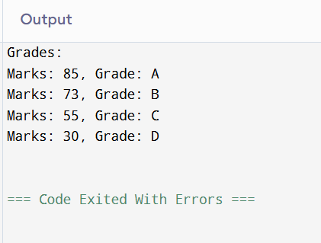

Q3:

#include <stdio.h>

void main() {

int marks[] = {88, 99, 75, 99, 60};

int n = sizeof(marks) / sizeof(marks[0]);

for (int i = 0; i < n; i++) {

if (marks[i] == 99) {

printf("First 99 scored at position: %d\n", i + 1);

break;

}

}

}

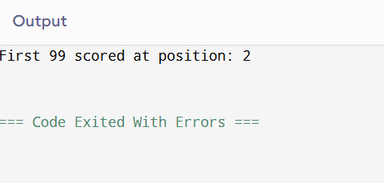

Q4:

#include <stdio.h>

void main() {

int marks[] = {88, 99, 75, 99, 60};

int n = sizeof(marks) / sizeof(marks[0]);

int count = 0;

printf("Positions of 99: ");

for (int i = 0; i < n; i++) {

if (marks[i] == 99) {

printf("%d ", i + 1);

count++;

}

}

printf("\nTotal 99s: %d\n", count);

}

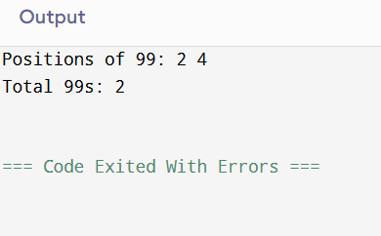

Q5:

#include <stdio.h>

void main() {

int marks[] = {45, 60, 75, 90};

int n = sizeof(marks) / sizeof(marks[0]);

int sum = 0;

for (int i = 0; i < n; i++) {

sum += marks[i];

}

printf("Sum of scores: %d\n", sum);

}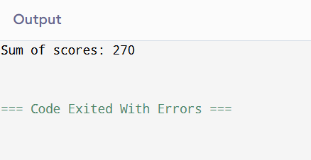

Q6:

#include <stdio.h>

void main() {

int marks[] = {45, 60, 75, 90};

int n = sizeof(marks) / sizeof(marks[0]);

int sum = 0;

for (int i = 0; i < n; i++) {

sum += marks[i];

}

printf("Average score: %.2f\n", (float)sum / n);

}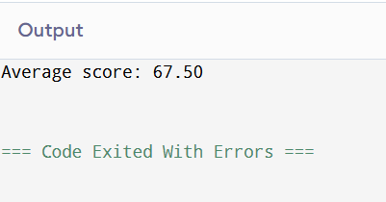

Q7:

#include <stdio.h>

void main() {

int marks[] = {45, 60, 75, 90};

int n = sizeof(marks) / sizeof(marks[0]);

printf("Even/Odd Check:\n");

for (int i = 0; i < n; i++) {

if (marks[i] % 2 == 0)

printf("%d is Even\n", marks[i]);

else

printf("%d is Odd\n", marks[i]);

}

}

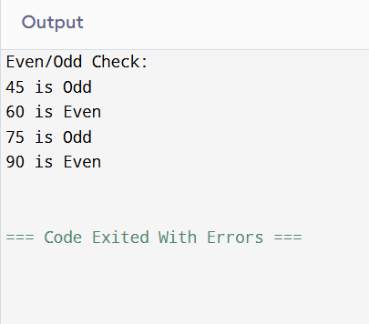

Q8:

#include <stdio.h>

void main() {

int marks[] = {45, 60, 75, 90};

int n = sizeof(marks) / sizeof(marks[0]);

int max = marks[0], min = marks[0];

for (int i = 1; i < n; i++) {

if (marks[i] > max)

max = marks[i];

if (marks[i] < min)

min = marks[i];

}

printf("Maximum Score: %d\n", max);

printf("Minimum Score: %d\n", min);

}

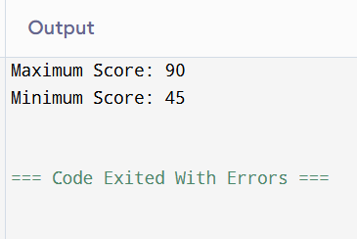

Q9:

#include <stdio.h>

void main() {

int marks[] = {10, 20, 15, 30, 25};

int n = sizeof(marks) / sizeof(marks[0]);

for (int i = 0; i < n; i++) {

if ((i == 0 || marks[i] >= marks[i - 1]) && (i == n - 1 || marks[i] >= marks[i + 1])) {

printf("Peak Element: %d\n", marks[i]);

break;

}

}

}

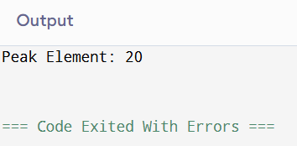

Q10:

#include <stdio.h>

#include <math.h>

int isPrime(int num) {

if (num <= 1)

return 0;

for (int i = 2; i <= sqrt(num); i++) {

if (num % i == 0)

return 0;

}

return 1;

}

void main() {

int marks[] = {2, 3, 4, 5, 6, 7};

int n = sizeof(marks) / sizeof(marks[0]);

int count = 0;

for (int i = 0; i < n; i++) {

if (isPrime(marks[i]))

count++;

}

printf("Prime Count: %d\n", count);

}

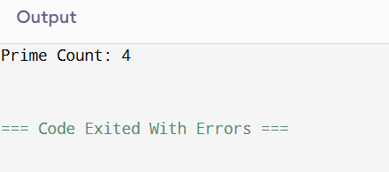

Q11:

#include <stdio.h>

void displayArray(int arr[], int size) {

for (int i = 0; i < size; i++) {

printf("%d ", arr[i]);

}

printf("\n");

}

void insertElement(int arr[], int \*size, int pos, int element) {

for (int i = \*size; i > pos; i--) {

arr[i] = arr[i - 1];

}

arr[pos] = element;

(\*size)++;

}

int main() {

int arr[100] = {1, 2, 3, 4, 5};

int size = 5;

printf("Array before insert: ");

displayArray(arr, size);

// Insert at front

insertElement(arr, &size, 0, 10);

// Insert at position 3

insertElement(arr, &size, 3, 20);

// Insert at end

insertElement(arr, &size, size, 30);

printf("Array after insert: ");

displayArray(arr, size);

return 0;

}

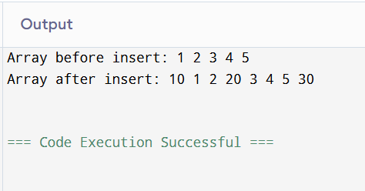

Q12:

#include <stdio.h>

void displayArray(int arr[], int size) {

for (int i = 0; i < size; i++) {

printf("%d ", arr[i]);

}

printf("\n");

}

void deleteElement(int arr[], int \*size, int pos) {

for (int i = pos; i < \*size - 1; i++) {

arr[i] = arr[i + 1];

}

(\*size)--;

}

int main() {

int arr[100] = {1, 2, 3, 4, 5};

int size = 5;

printf("Array before delete: ");

displayArray(arr, size);

// Delete from front

deleteElement(arr, &size, 0);

// Delete from position 2

deleteElement(arr, &size, 2);

// Delete from end

deleteElement(arr, &size, size - 1);

printf("Array after delete: ");

displayArray(arr, size);

return 0;

}

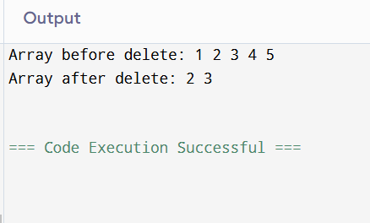

Q13:

#include <stdio.h>

void displayArray(int arr[], int size) {

for (int i = 0; i < size; i++) {

printf("%d ", arr[i]);

}

printf("\n");

}

void rotateClockwise(int arr[], int size) {

int last = arr[size - 1];

for (int i = size - 1; i > 0; i--) {

arr[i] = arr[i - 1];

}

arr[0] = last;

}

int main() {

int arr[] = {1, 2, 3, 4, 5};

int size = 5;

printf("Original array: ");

displayArray(arr, size);

rotateClockwise(arr, size);

printf("Rotated array: ");

displayArray(arr, size);

return 0;

}

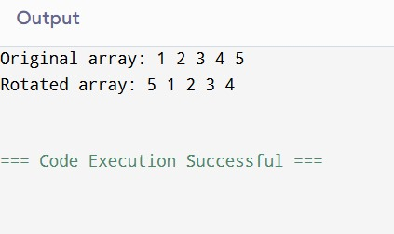

Q14:

#include <stdio.h>

void findDuplicates(int arr[], int size) {

int foundDuplicate = 0;

printf("Duplicates: ");

for (int i = 0; i < size; i++) {

int count = 0;

for (int j = 0; j < size; j++) {

if (arr[i] == arr[j] && i != j) {

count++;

}

}

if (count >= 1) {

int alreadyPrinted = 0;

for (int k = 0; k < i; k++) {

if (arr[k] == arr[i]) {

alreadyPrinted = 1;

break;

}

}

if (!alreadyPrinted) {

printf("%d ", arr[i]);

foundDuplicate = 1;

}

}

}

if (!foundDuplicate) {

printf("-1");

}

printf("\n");

}

int main() {

int arr1[] = {2, 10, 10, 100, 2, 10, 11, 2, 11, 2};

int size1 = 10;

int arr2[] = {5, 40, 1, 40, 100000, 1, 5, 1};

int size2 = 8;

printf("Array 1: ");

findDuplicates(arr1, size1);

printf("Array 2: ");

findDuplicates(arr2, size2);

return 0;

}

